Shaik Sharifa Jahan

AP22110011103

1. Write a program in assembly code to multiply two 8 bit numbers.

org 100h

mov al,05h

mov bl,02h

mul bl

mov bl, al

mov ah, al

and ah, 0F0h

shr ah,4

add ah, 30h

cmp ah, 39h

jle print_first_digit

add ah, 7

print_first_digit:

mov dl,ah

mov ah,02h

int 21h

mov ah, bl

and ah, 0Fh

add ah, 30h

cmp ah, 39h

jle print_sec_digit

add ah,7

print_sec_digit:

mov dl,ah

mov ah, 02h

int 21h

mov ah,4Ch

int 21h

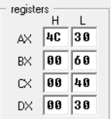

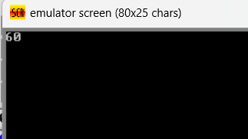

1. Write a program in assembly language to multiply to 16 bit numbers.

org 100h

mov ax,1580h

mov bx,1025h

mul bx

mov bx,ax

mov cx,dx

mov ah,ch

and ah,0f0h

shr ah,4

add ah,30h

cmp ah,39h

jle print_high_nibble32

add ah,7

print_high_nibble32:

mov dl,ah

mov ah,02h

int 21h

mov ah,ch

and ah,0fh

add ah,30h

cmp ah,39h

jle print_low_nibble32

add ah,7

print_low_nibble32:

mov dl,ah

mov ah,02h

int 21h

mov ah,cl

and ah,0f0h

shr ah,4

add ah,30h

cmp ah,39h

jle print_high_nibble24

add ah,7

print_high_nibble24:

mov dl,ah

mov ah,02h

int 21h

mov ah,cl

and ah,0fh

add ah,30h

cmp ah,39h

jle print_low_nibble24:

add ah,7

print_low_nibble24:

mov dl,ah

mov ah,02h

int 21h

mov ah, bh

shr ah, 4

add ah, 30h

cmp ah, 39h

jle print_high_nibble16

add ah, 7

print_high_nibble16:

mov dl, ah

mov ah, 02h

int 21h

mov ah, bh

and ah, 0fh

add ah, 30h

cmp ah, 39h

jle print_low_nibble16

add ah, 7

print_low_nibble16:

mov dl, ah

mov ah, 02h

int 21h

mov ah, bl

shr ah, 4

add ah, 30h

cmp ah, 39h

jle print_high_nibble8

add ah, 7

print_high_nibble8:

mov dl, ah

mov ah, 02h

int 21h

mov ah, bl

and ah, 0fh

add ah, 30h

cmp ah, 39h

jle print_low_nibble8

add ah, 7

print_low_nibble8:

mov dl, ah

mov ah, 02h

int 21h

mov ah,4ch

int 21h

